***Technology management***

***Summer semester***

***Group assignment***

Vaania asif 221438858

Muhmmad ahmad 231467550

Muhammad Mustafa 231469864

***Project 1***

***Project and Tasks:***

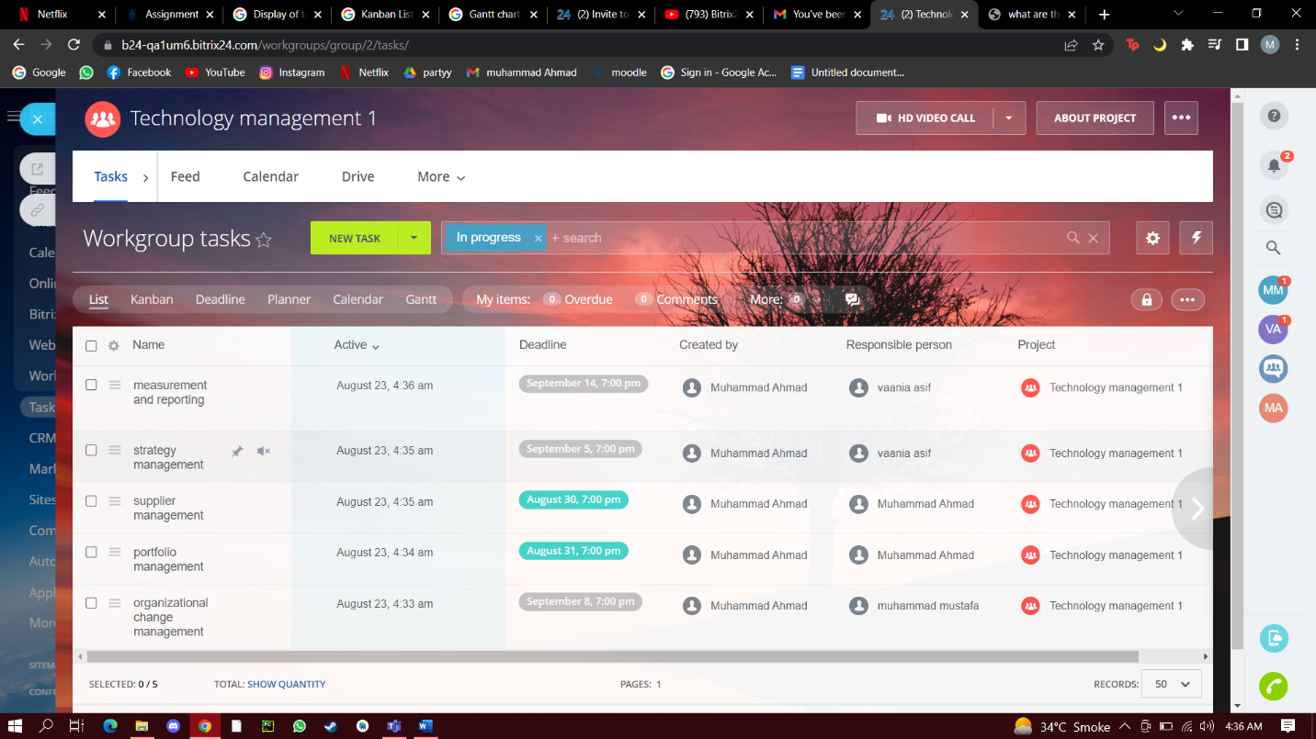

***Kanban list:***

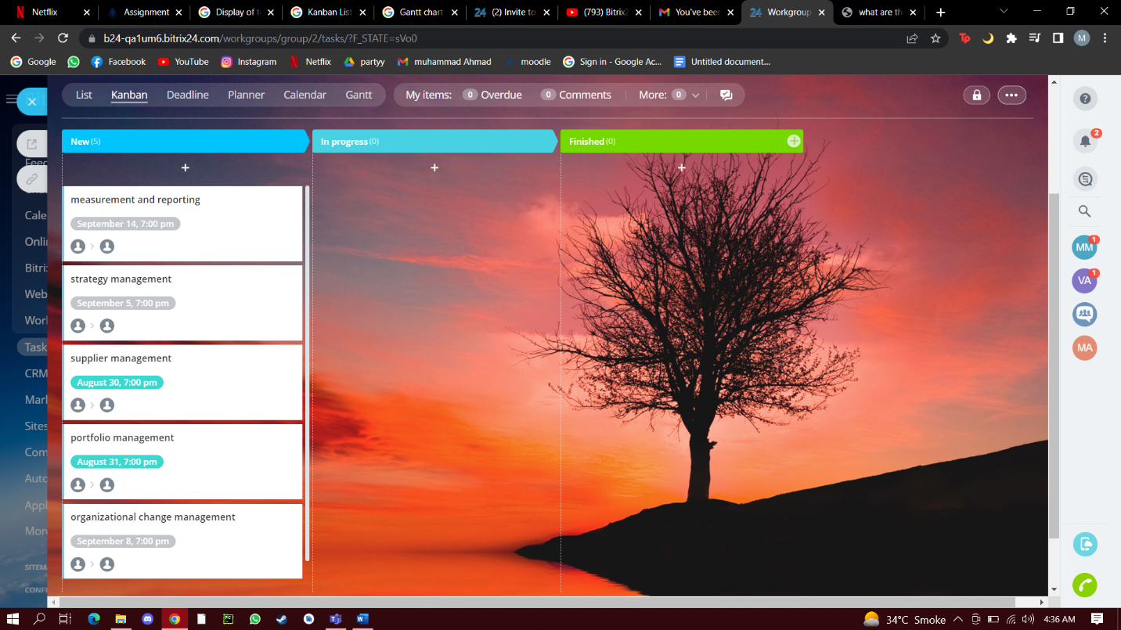

***Gantt Chart:***

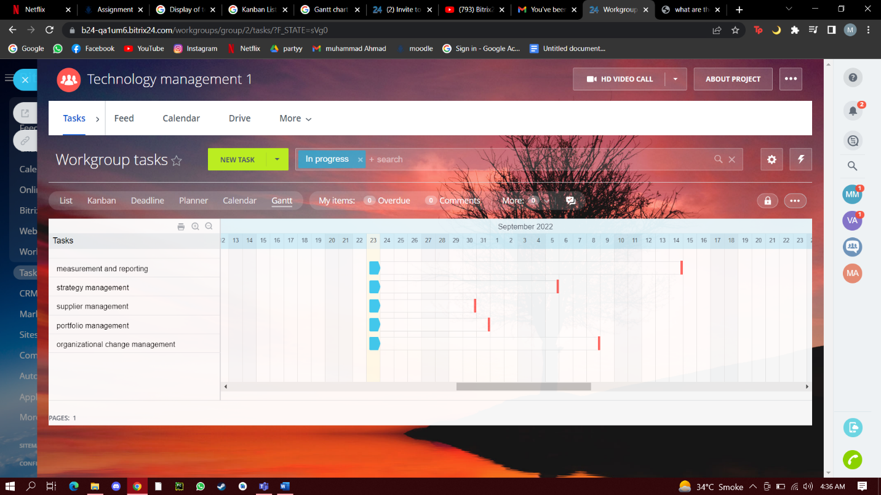

***Additional reports:***

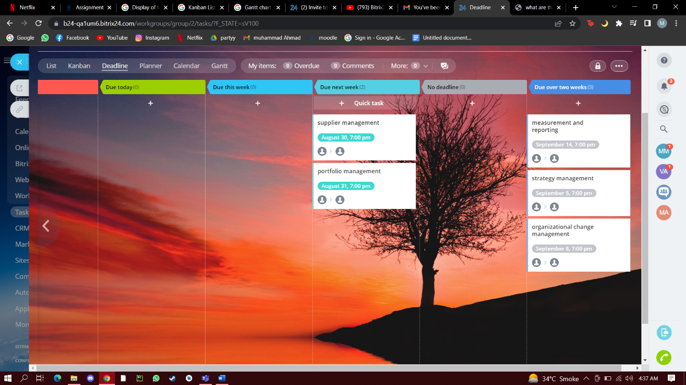

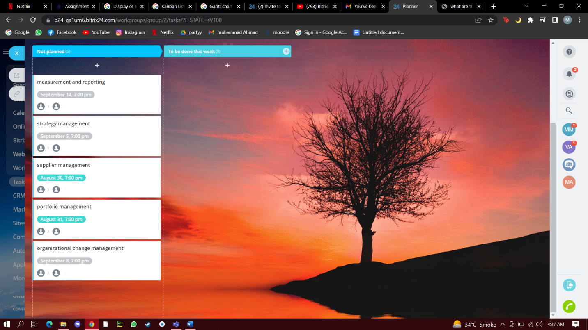

***Project 2***

***Project and Tasks:***

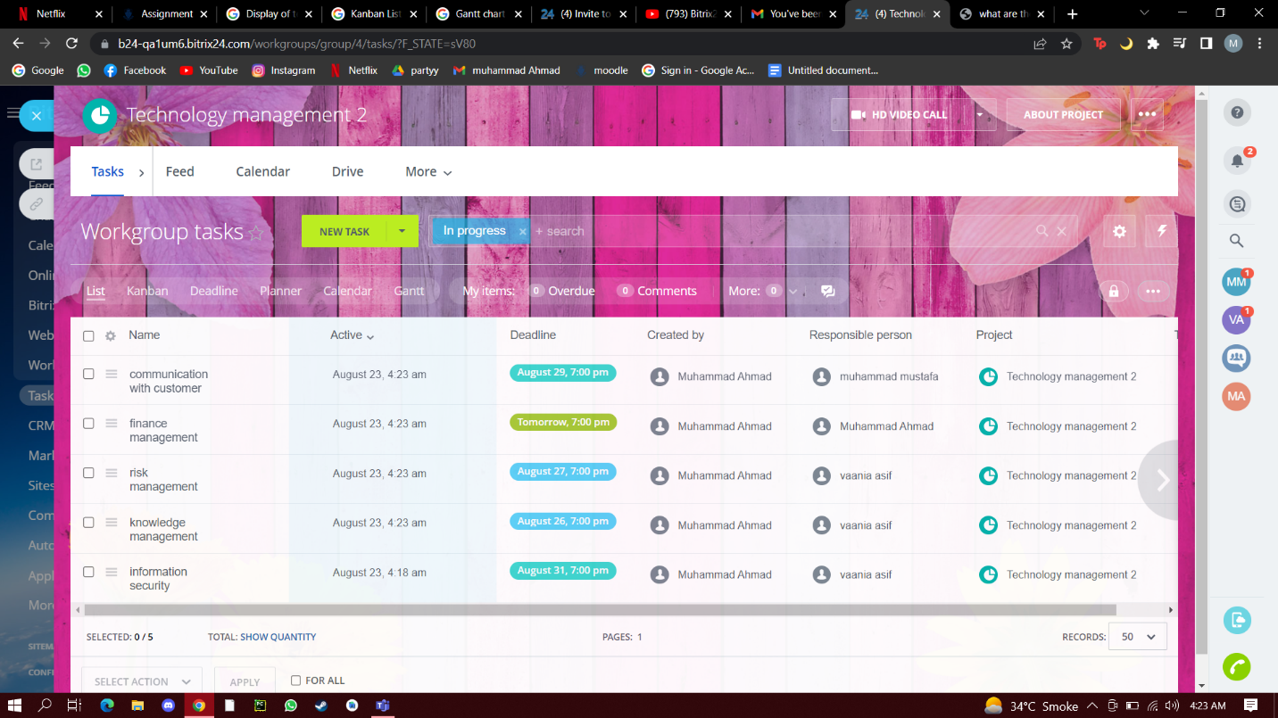

***Kanban list:***

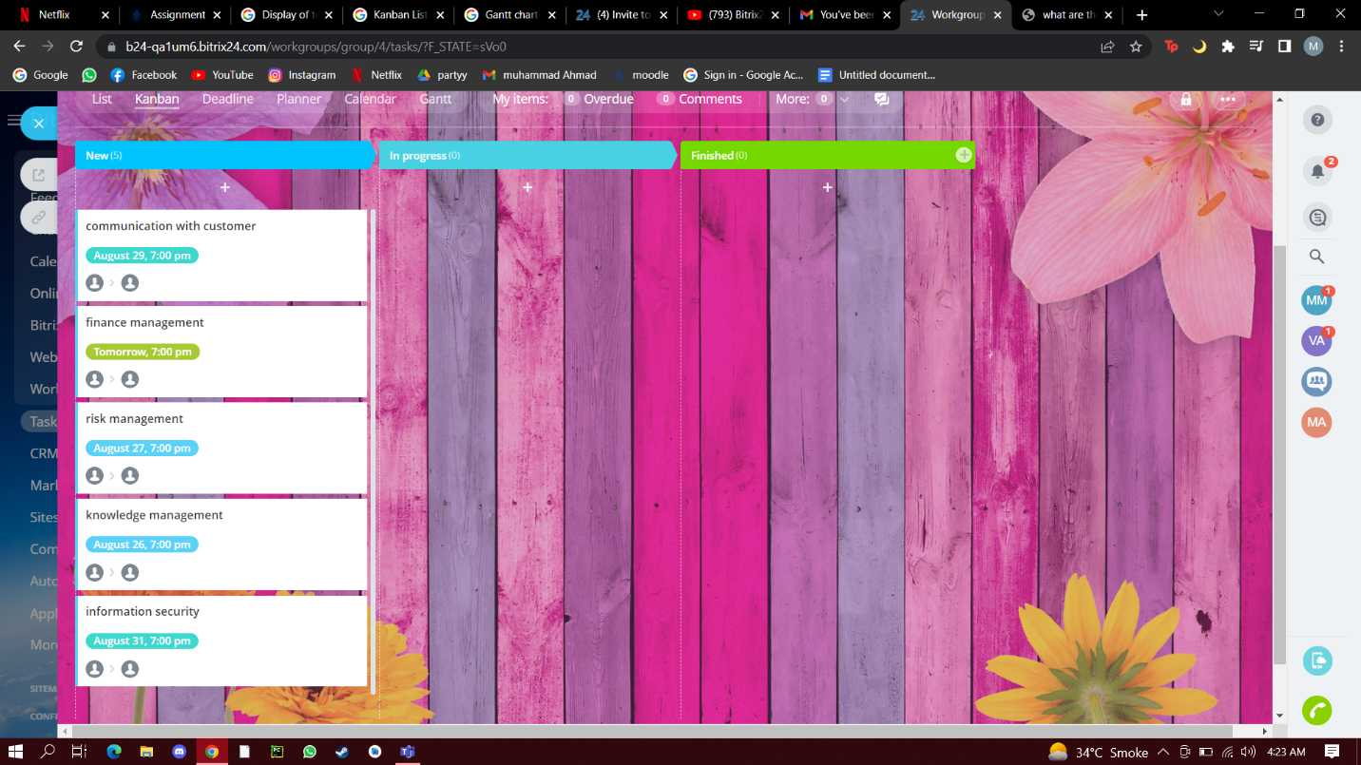

***Gantt Chart:***

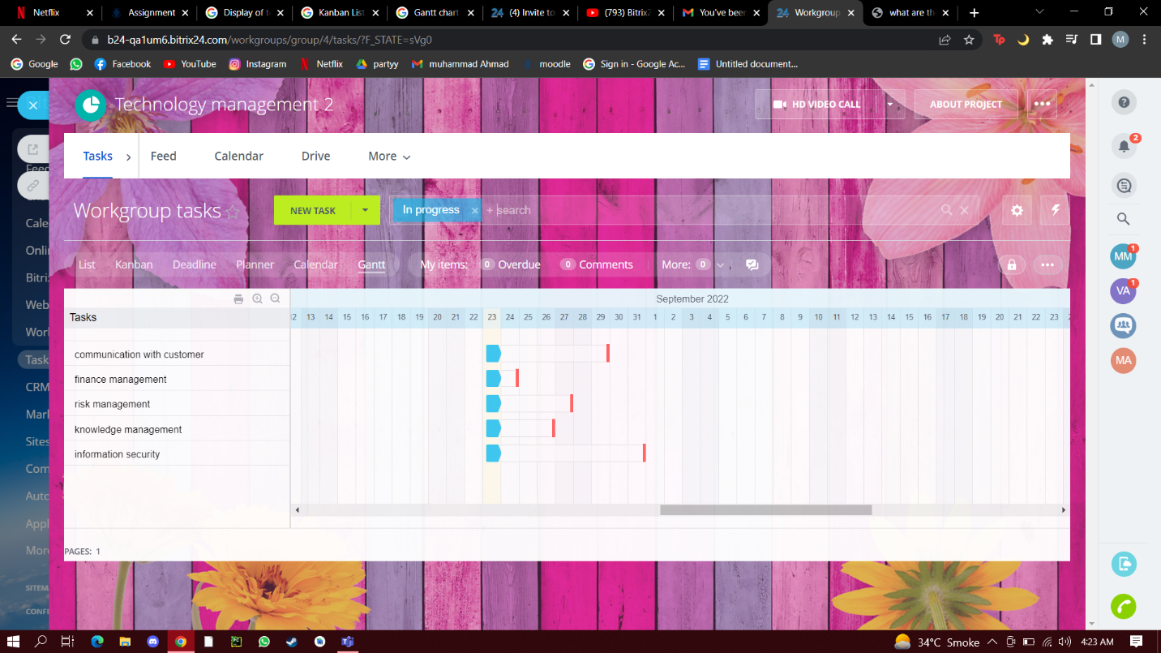

***Additional reports:***

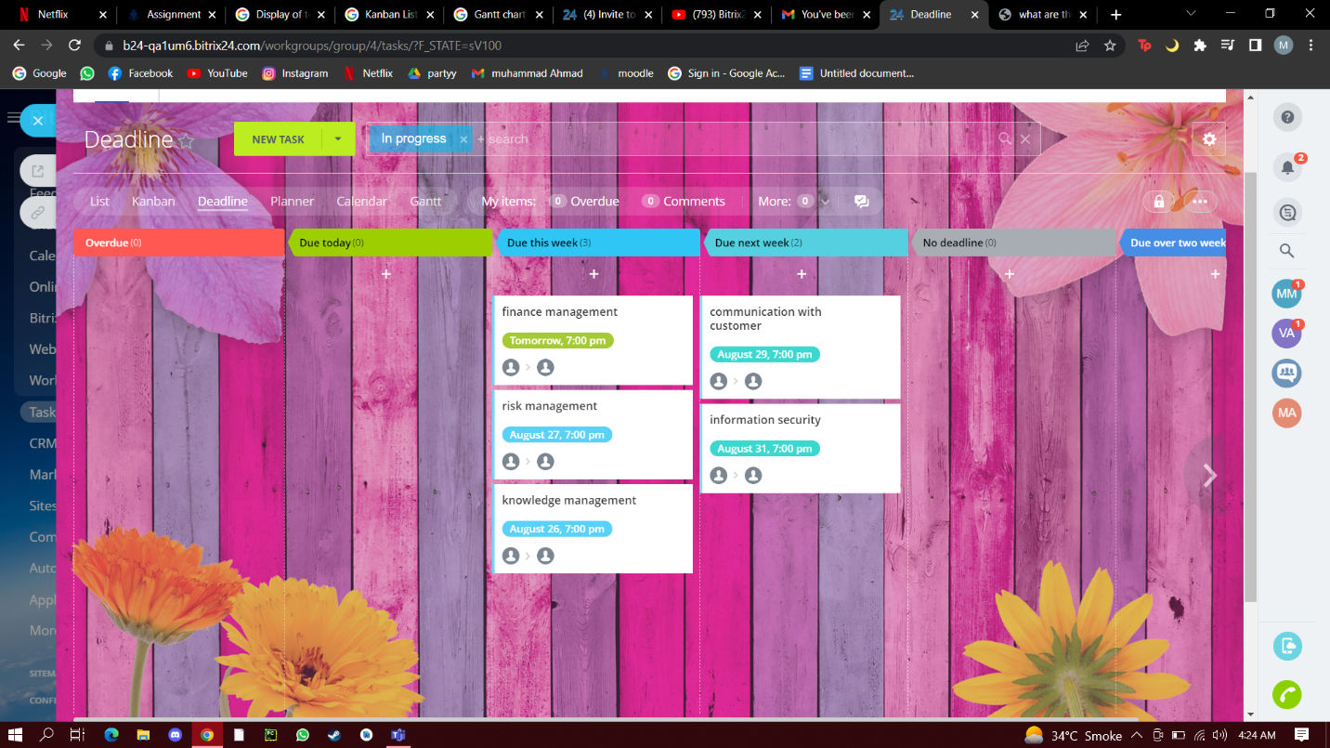

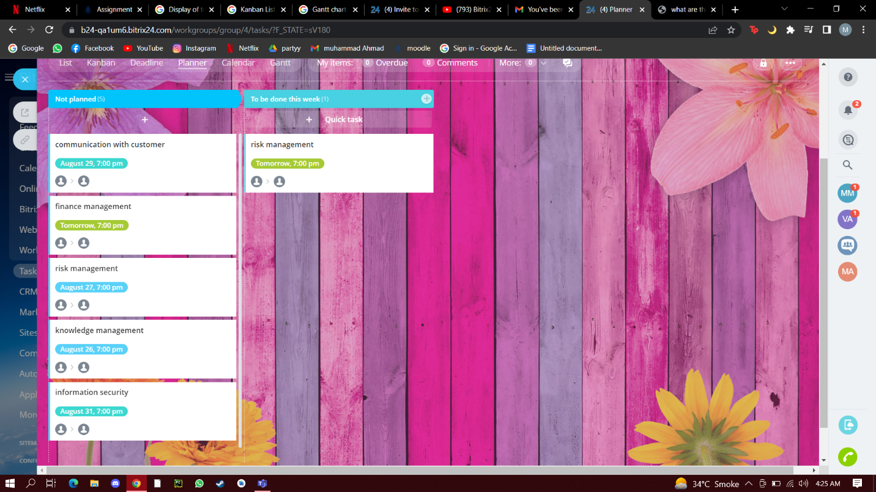

***Scrum report***

